Youth Room Revamp

Request by: Rev. Elizabeth Eckman & Stephanie Alsvan
Date: August 6, 2021

Proposal: For Council to approve financial support from endowment in order to re-envision and update the Youth Room.

As we enter into the fall with new ideas and hope for engaging our youth in meaningful experiences, we seek to update the youth space. Having a dedicated space for the youth is important for them to feel as though they have ownership as a part of the church as well as a comfortable space to be vulnerable and connect with God. Our desire is for this space to feel and look more like the spaces our youth interact with every day. A place that is welcoming and stylish, a place where we can be serious about God, and have fun and eat snacks. Many of the couches have been used and well loved by the Children's Garden, as well as placed in the garage. The items in the garage will be disposed of. We have an opportunity to update furniture and rethink the way the room is arranged in light of COVID-19 concerns and needing to purchase newer items. We would like to paint the walls as well.

Cost = up to $8,000
Trustees have discussed paying for this out of the endowment if approved by council.

Timeline: As soon as approved

Below is a Rough design of what the room could look like with arrangement.

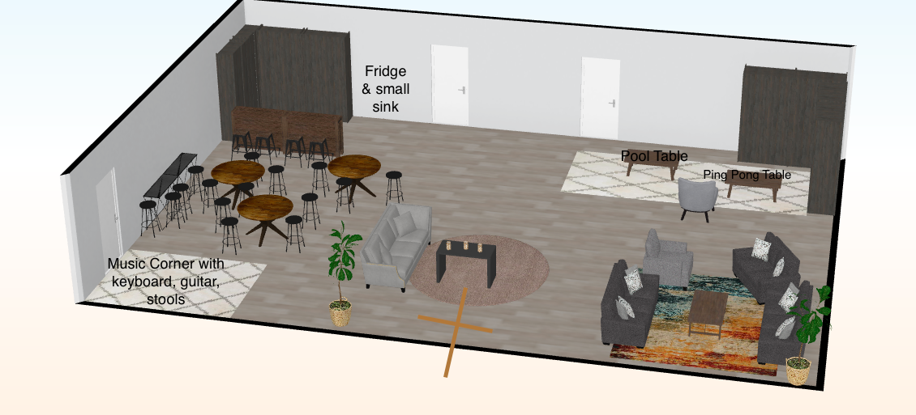
*note- online program would not let me change wall color or floor. Wall color would be subject to change, and floor would stay the same. Larger carpets & area rugs would desire to be purchased.

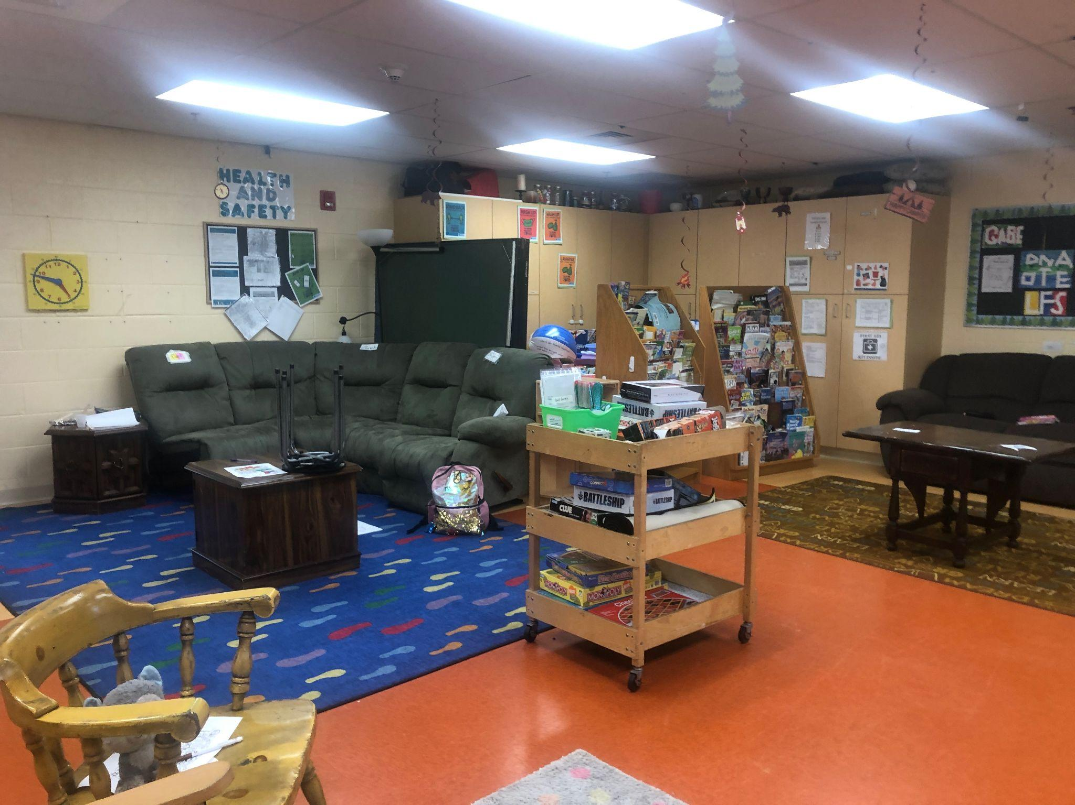
Current Youth Room
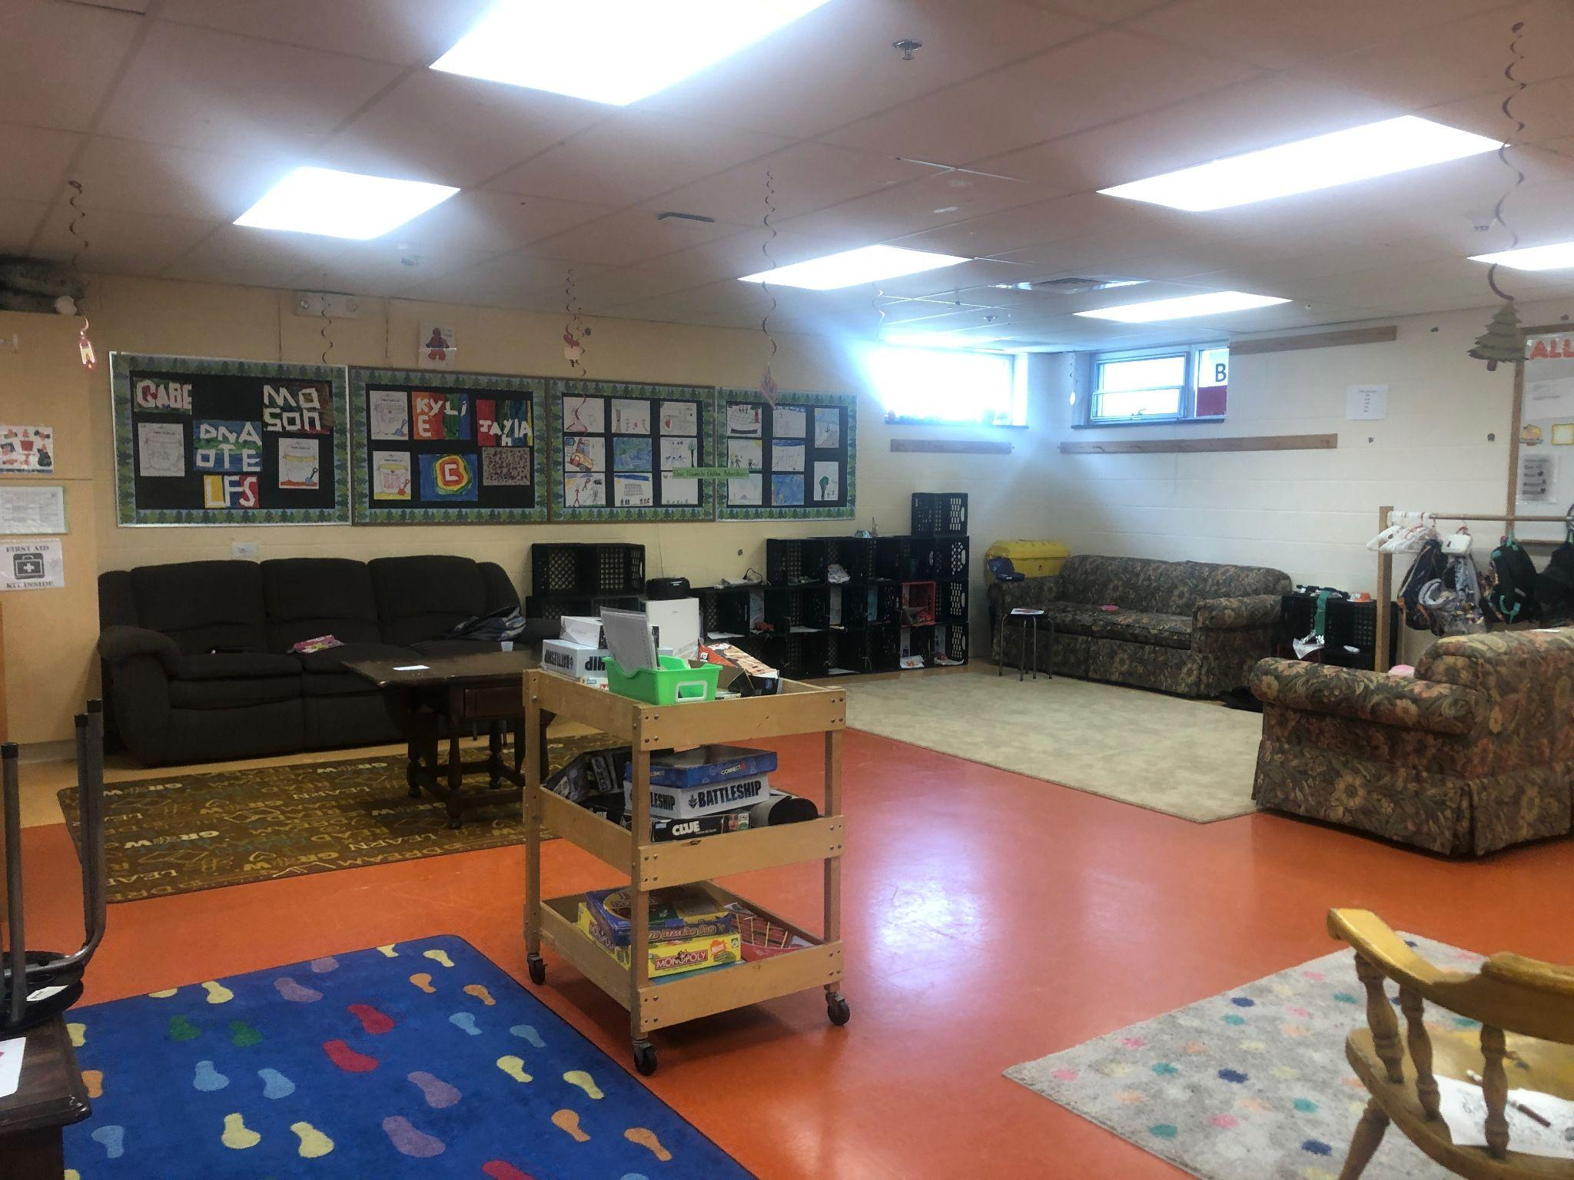
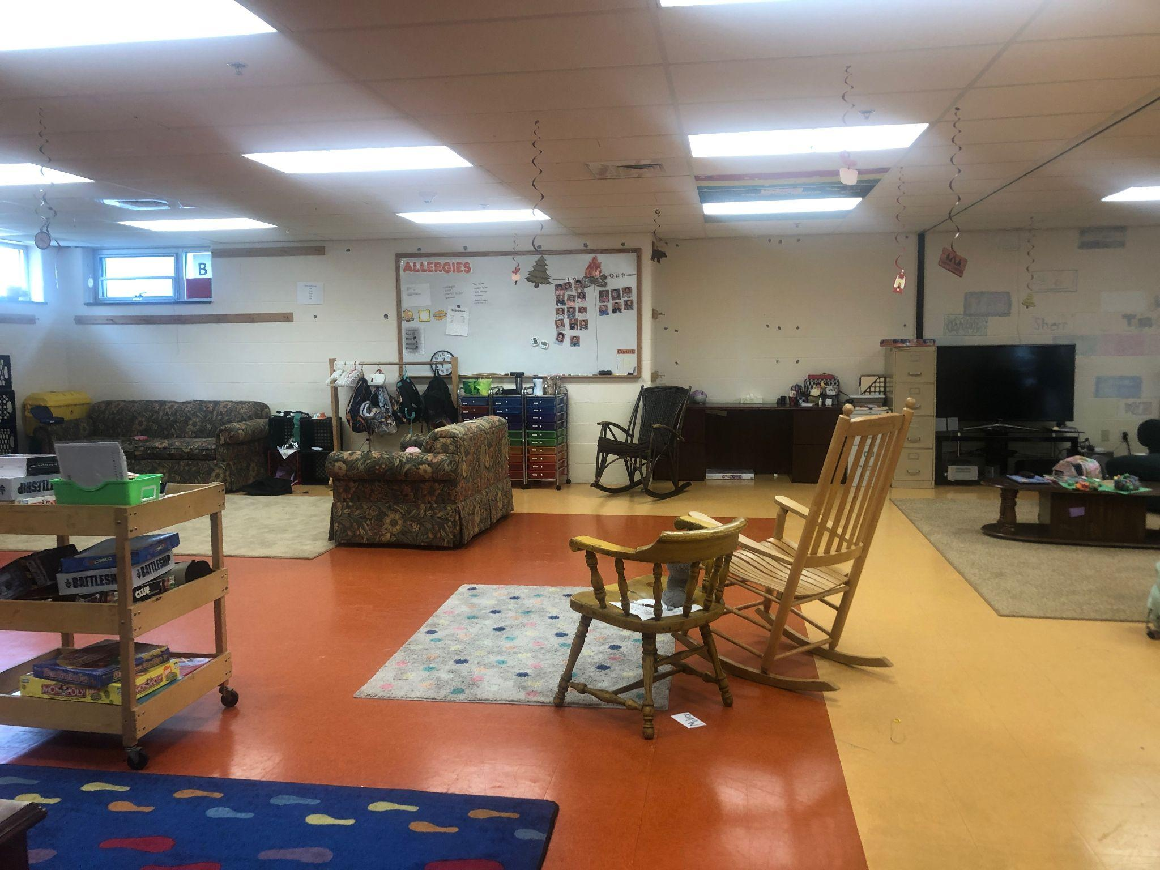
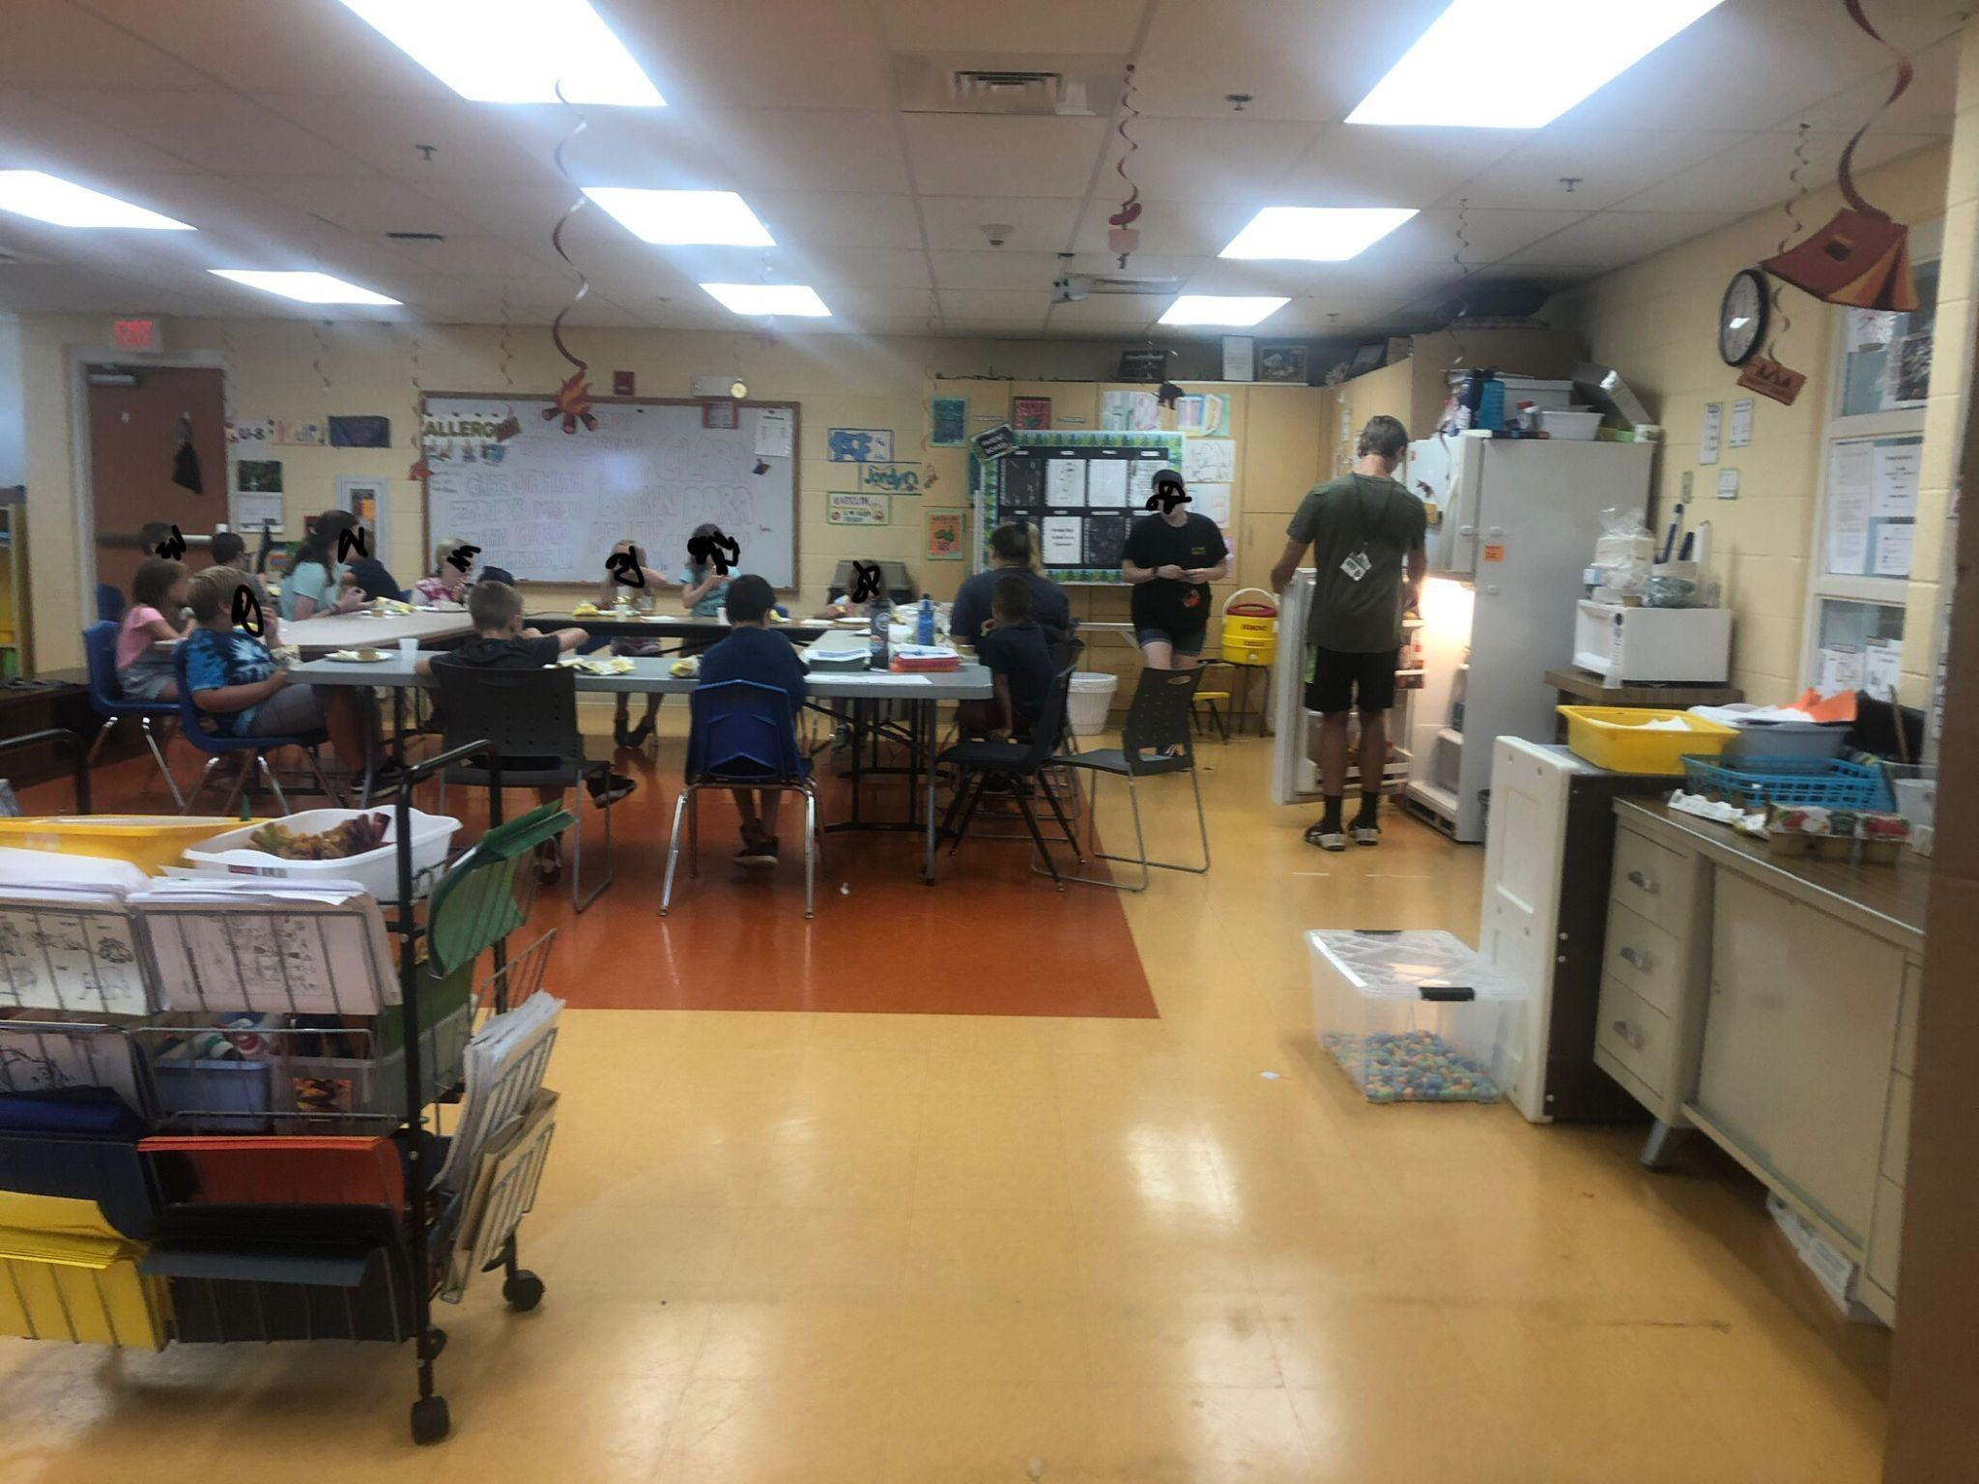
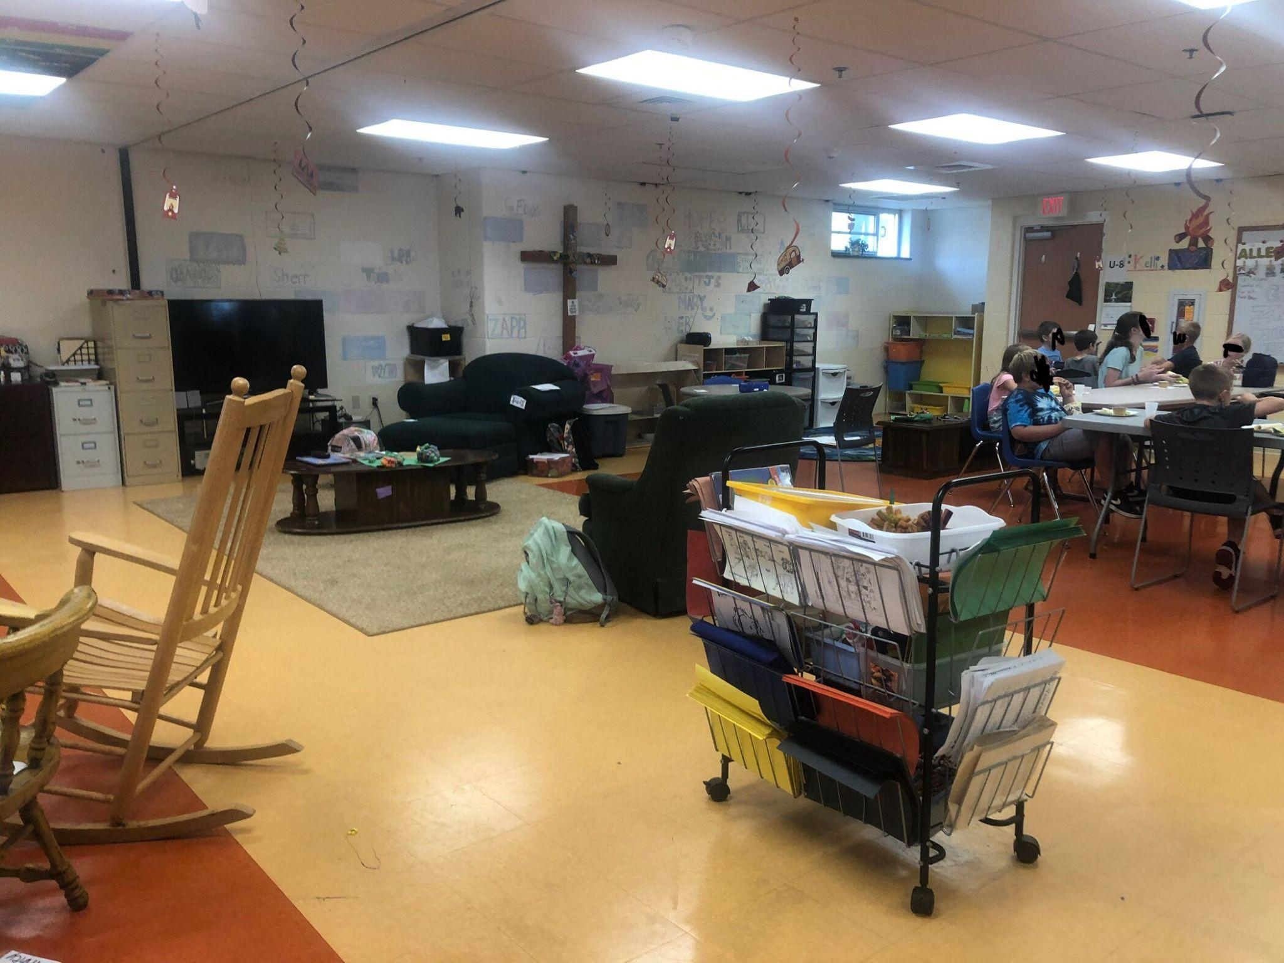
*many of the items in these pictures are children’s gardens and will be removed in the coming weeks

